Current set up of routers and switches of E1019
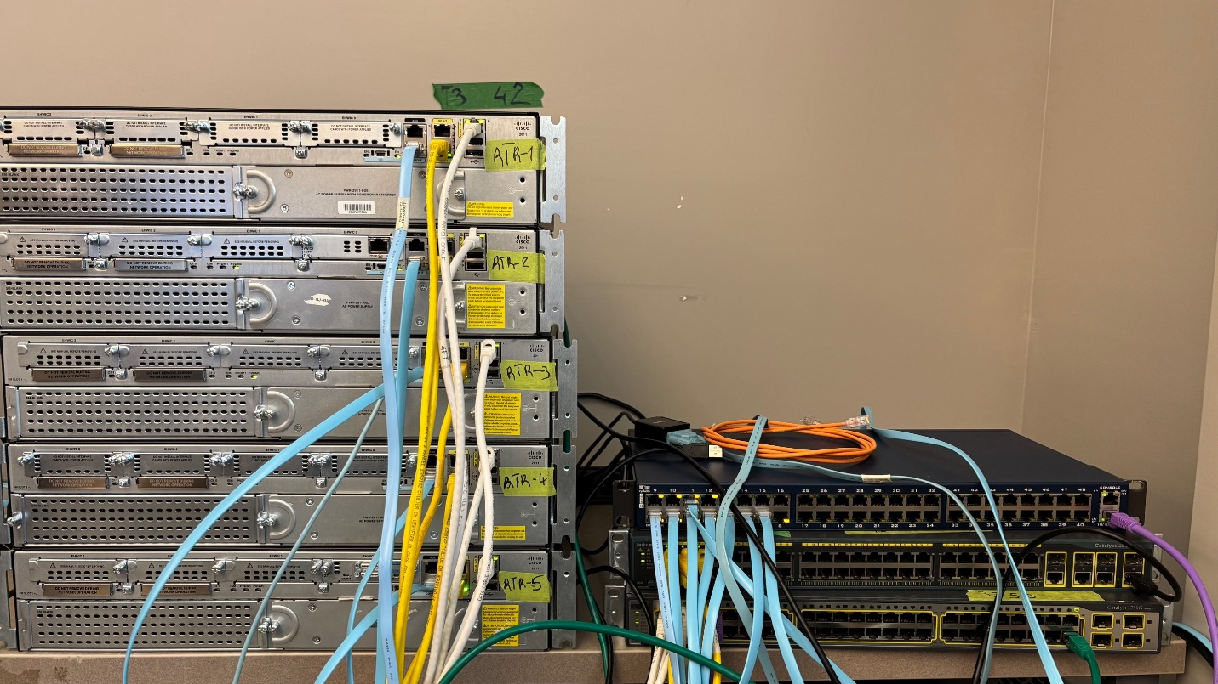
Router configured according to the specification.
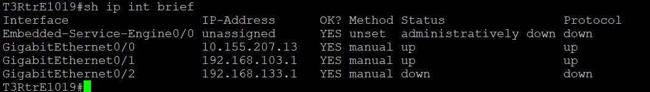

This is the current running config.
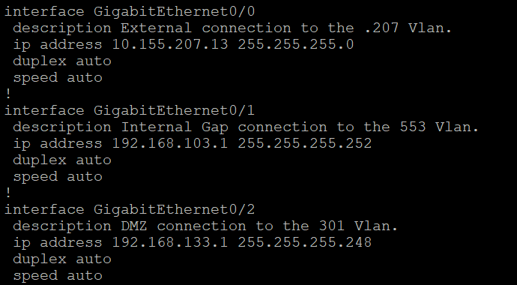
No password was set at this time for simplicity.

The router is also accessible through the Cyclades box 10.155.207.2 port 7003 by using Putty.
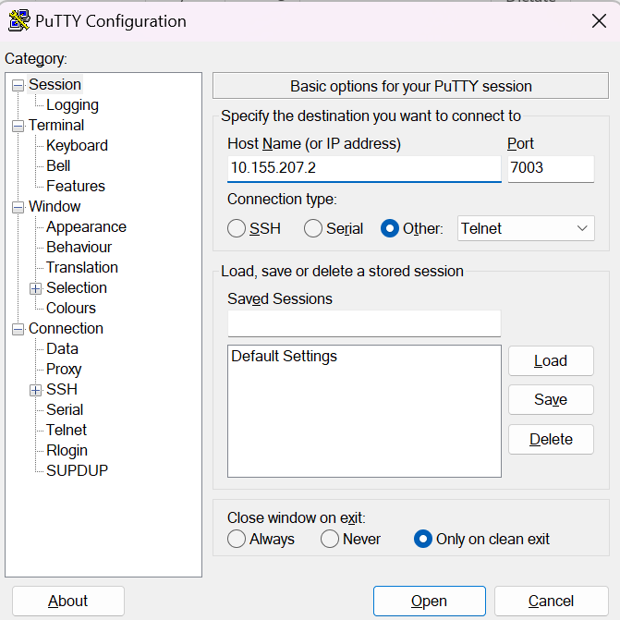

Remote access running.
Current running config on T3RtrC1002
Current Vlan’s with assigned ports on C1002-APPstd-IntSW3

UBUNTU INSTALLATION
IP ADDRESS SETUP

